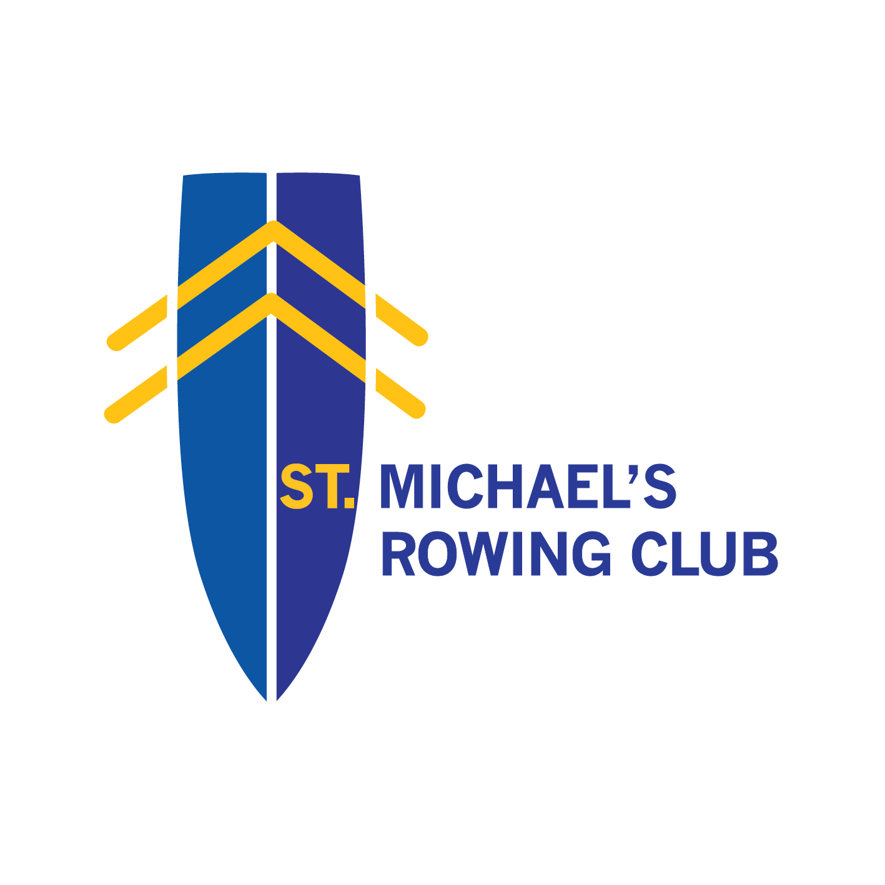
*** SMRC URBAN RUN PRESS RELEASE ***

Your Chance to Race an Olympian !

St. Michael’s Rowing Club are pleased to announce details of their annual 5km and 10km Urban Run. The urban run race is scheduled to take place on Sunday, October 8th 2017. The flat course, which is ideal for those looking for PBs as it starts on O’Callaghan Strand and makes use of the NCRd and scenic riverbank along the Condell Road finishing at the rowing clubhouse. Now in its 5th year, the popular event continues to grow year on year with an estimated entry of over 600 runners for 2017.

The event is a well needed fundraiser for the rowing club but it also raises funds for the Limerick Suicide Watch and their vital work on the riverfront. St. Michael’s are delighted to be once again partnering with LSW, from which many volunteers will be helping on the day or running in the events themselves. A truly local partnership in the heart of the city.

Irish Olympian Sinead Lynch will once again lead the charge of the competitors from the rowing club. Sinead placed 6th along with her double scull partner Claire Lambe in the 2016 Rio Olympics and is a former rowing world champion. Fear not if you think you won’t be able to pace anywhere near the superstar athlete as she will be racing with 2 of her daughters in a pushchair. Don’t say she didn’t give you a fighting chance.

Local running groups, schools groups, including Laurel Hill, as well as a very large contingent from St. Michael’s itself will pound the pavement in what is fast becoming one of the region’s most popular road races.

The St. Michael’s clubhouse will offer bag storage for competitors. The club’s volunteers made up of parents, coaches, committee and rowers will be on hand to pass out water to the competitors as well as the much needed cups of tea, coffee and a bit of caca milis at the end to help finish off what will be a great afternoon of racing in the city.

Registration is now open at http://www.smrc.ie/urbanrun/ and registration can also be made on the morning of the event in the rowing club. More details can be found on www.smrc.ie.



