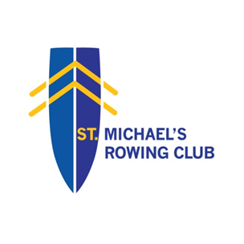

SMRC COVID GUIDANCE – Revised September 2021 in line with Government Resilience and Recovery Plan 2020-2021, Plan for living with COVID-19 and Sport Ireland / Rowing Ireland Guidelines
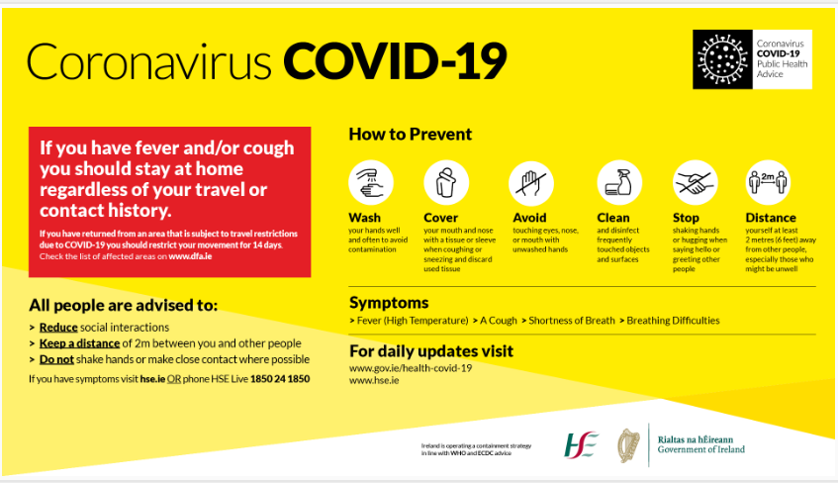

General Guidelines:

From September 20th organised indoor sport can take place with capacity limits of 100 people (with appropriate protective measures) where all are immune (fully vaccinated or recovered from COVID-19 within the previous 6 months).
Where members aren’t immune they are permitted to train indoors in pods of 6.
Multiple pods are permissible subject to adequate protective measures being in place.
Changing rooms and showers can be used. Limited numbers allowed and short duration only, Sport Ireland recommend ‘15min in room / 5 min max in shower’ rule.
Sport Ireland and Rowing Ireland guidance on COVID have been taken into account in this guide. Please note guidelines may change should the public health advice change.
From October 22nd the government are removing the following restrictions:
- Formal requirements for physical distancing
- Formal requirements for mask wearing outdoors
- Restrictions on indoor sport activities
Sport Clubs must continue to:
Maintain overarching structures to reduce the risk to members from COVID-19 including:
- Maintain a competent COVID 19 Officer
- Recommending symptomatic members do not attend training
- Ongoing promotion of good respiratory and hand hygiene
- Wearing of face masks in particular circumstances indoors
- Considering of air flow / changes in indoor facilities and adjusting ventilation, training numbers etc. to minimise risk
- Appropriate cleaning of sports equipment after use

- All rowers/coaches must be made aware of rules and complete declaration of familiarity and confirm they, or their family members, have not had symptoms of COVID-19 in the previous 14 days.
- All members are strongly encouraged to avail of vaccine when available to them.
- If you, or a family member, have any symptoms related to Covid 19 do not attend for training - e.g. a fever (high temperature - 38 degrees Celsius or above) / a cough - this can be any kind of cough, not just dry / shortness of breath (breathing difficulties), loss of sense of taste or smell.
- If anybody gets symptoms of COVID-19 while at the club then they should be isolated outside or in Committee Room and a member of their family contacted immediately. Any close contacts should contact public health authorities for advice if self-isolation is necessary. Isolation room, and any room suspect COVID case used, to undergo deep clean before being put back into use.
- Any member in a ‘vulnerable group’ medically should seek confirmation / approval from their doctor before attending and advise club officers if appropriate.
- In circumstances where first aid is required, first aider must use appropriate gloves and mask.
- Coaches must clean down contact areas in launch with disinfectant wipes/spray before and after each use.
- Regular club rules around rowing activities still apply including:
  - must be able to swim min. 50m
  - bow balls, hatch covers, heel restraints and quick release cords must be in place
  - launch must be within safe distance of boats
  - safety kit must be in launch
  - river directional routes apply
  - coaches to wear life jackets and have radios etc.
- SAFETY CHECK (of above) to be done on EVERY BOAT, EVERY TIME it’s being used.
Rowing Ireland protocols to be followed https://www.rowingireland.ie/wp-content/uploads/2021/04/Rowing-Ireland-Protocols-ROI-Apr-26th.pdf

